Inventrom Site Website Development

### As part of this task, you have to design a single page UI of [www.inventrom.com](http://www.inventrom.com) site using HTML, CSS and JavaScript.

So basically Inventrom site will have 6 components.

1. Navigation Bar
2. Background image with Text section
3. About US section
4. Awards section
5. Contact
6. Footer

## 

**1.Navigation Bar**

Navigation bar will have one logo and three links and when you click on these link it will scroll the page to the respective section.

For example: When you click on About section, it will scroll the page to About US section.

**Demo:** Open this site <https://www.boltiot.com/>, when you click on the Features, it scrolls down the Features section of the page.

**2. Background image with Text section**

This section will have one image in the background and some text on top of the image.

Check the image below.

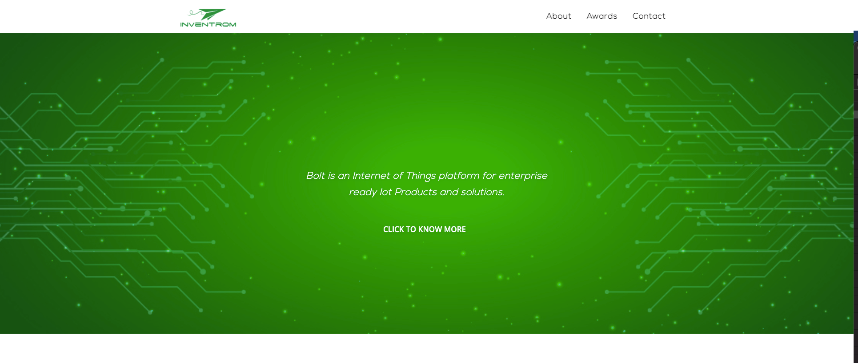

**3. About US**

About Us section will have some details about Bolt Platform then just below the details there will be two cards.

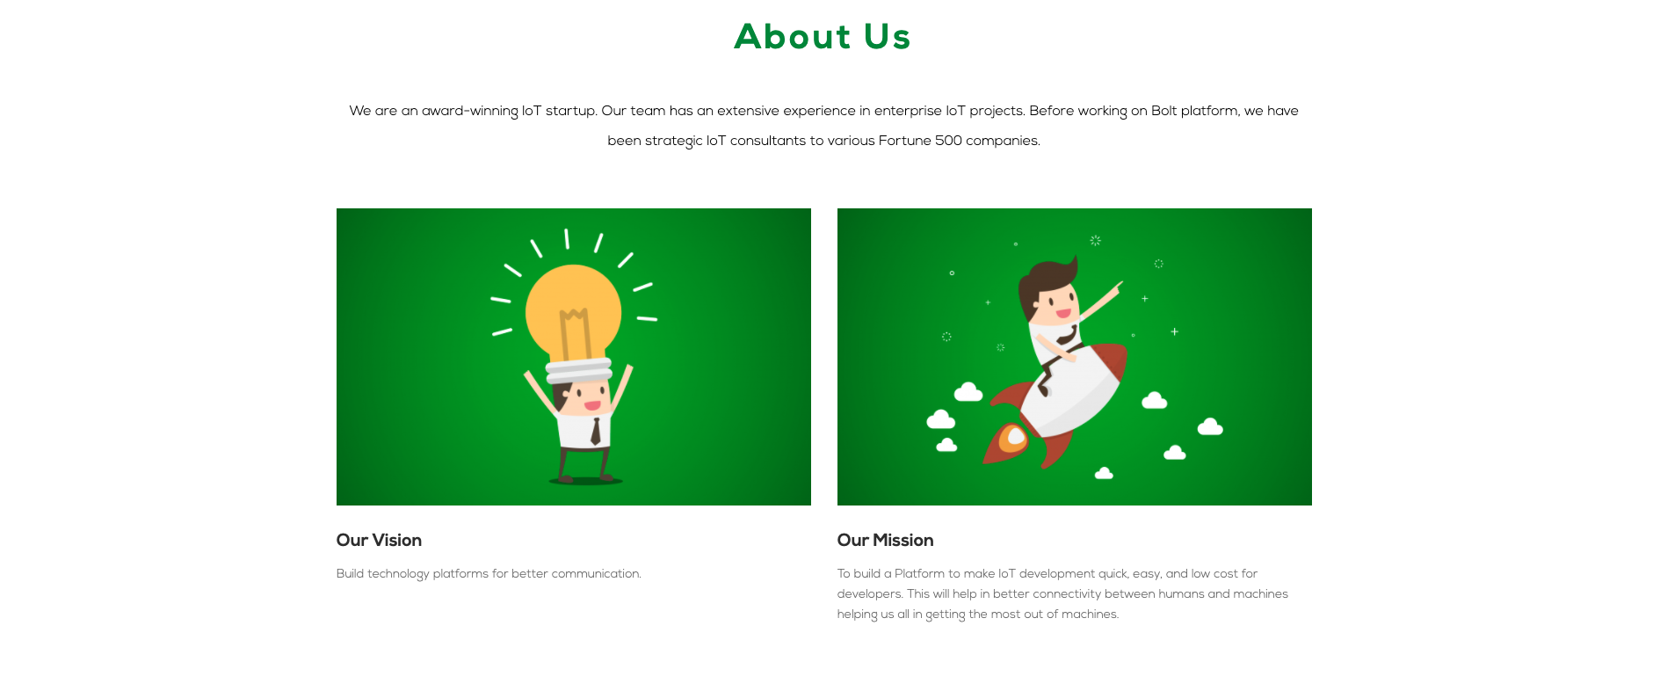

**4. Awards Section**

Here you have to add the details about Awards. Just below each image, there will be the test as shown in the below picture.



**4. Get in touch section:**

In this section, you will have a Hubspot form in the left hand side and in the right hand site Locations and contact details.

To embed the Hubspot form in your code just enter the below code snippet in your html code and it will work.

<!--[if lte IE 8]>

<script charset="utf-8" type="text/javascript" src="//js.hsforms.net/forms/v2-legacy.js"></script>

<![endif]-->

<script charset="utf-8" type="text/javascript" src="//js.hsforms.net/forms/v2.js"></script>

<script>

hbspt.forms.create({

portalId: "4801849",

formId: "b021b49f-c504-4b1d-ad2b-1bb9e587287c"

});

</script>

**Note: The above form will not show up when you open your index.html file in chrome, but it will work when you make it live on the server. You can try it out over here** [**https://www.hostatic.com/**](https://www.hostatic.com/)

**So what you can do here:** You can make a div on left side of the page with specific width and then add the form code snippet inside the div.

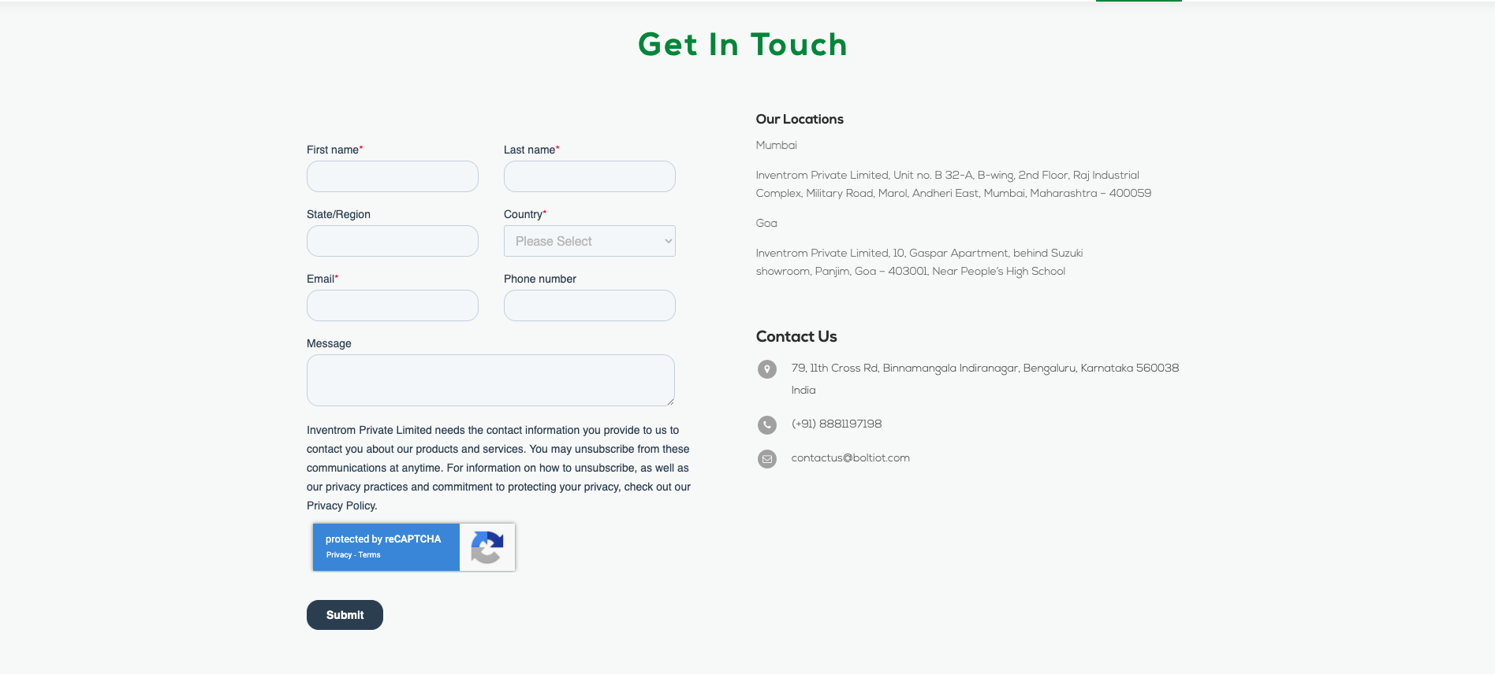

**Footer:**

Footers of the page will have copyright text and social icons.



## Design color schemes:

1. Navigation menu text color: #0a0a0a
2. Section main text color: #139139
3. Footer background color **:** #139139
4. Other text: #000000